TOTHBOT
KRAKEN SYSTEM ARCHITECTURE OVERVIEW
The Complete System — All Architectural Decisions + All Flow Diagrams

DocDCN: | 0500000
DocTitle: | TothBot_Kraken_System_Architecture_Overview
DocVersion: | dv1_5
DocOwner: | Bill
DocPath: | GitHub.com/TothBot/TothBot-V2-Docs/05XXXXX_System_Architecture/0500000_System_Architecture_Overview_dv1_5.docx
DocDate: | 03-24-2026
DocTime: | 23:59:59 UTC

PURPOSE: This document captures all architectural decisions, FP/DP analyses, and system specifications from the TothBot Kraken architecture sessions of March 2026. Includes all six system flow diagrams showing connections between Kraken, TothBot, and CIATS as one unified organism.

Diagrams in this document (dv1_5 — all updated):
- Diagram 1 — Kraken API Connection Architecture (dv1_5: ohlc(60) added, GetOHLCData daily regime, WS dispatch table)
- Diagram 2 — TothBot Trading Pipeline (dv1_5: 8 gates, Regime Pre-Filter Gate 3, pre-computation cache, ATR incremental)
- Diagram 3 — Exit Architecture: Ground Zero Redesign (dv1_5: Layer 2 cancel timeout fallback)
- Diagram 4 — Regime Taxonomy: 6-Regime Grid + Two-Level Tagging (dv1_5: REST GetOHLCData data source documented)
- Diagram 5 — CIATS Architecture: Data Flows and Improvement Cycle (dv1_5: async Logger, Parameter Store snapshot)
- Diagram 6 — Complete System: One CIATS-Owned Organism (dv1_5: all dv1_5 changes integrated)

1. System Identity and Mission

1.1 What TothBot Is
TothBot is an automated cryptocurrency spot trading system on Kraken exchange. It runs 24/7/365 on a Hetzner VPS, processes 5-minute OHLC candle close events as its system clock, and executes long-only trades using a momentum-based signal engine.
TothBot is not an external system connected to Kraken — it IS Kraken's event processor. Every action is a response to a Kraken push event. No timers. No polling. Idle and silent until Kraken speaks.

1.2 The One Organism Principle
Three functional zones, one organism:
- Kraken: generates events, executes orders, holds resting TP limit orders and off-book emergency SL stop orders on matching engine
- TothBot: processes Kraken events, executes trading strategy, manages positions
- CIATS: learns from event records, continuously improves processing rules

PRIMARY MISSION: Maximize profit. Minimize loss. With an emphasis on minimizing loss. Loss prevention takes priority over profit generation. Everything else is secondary.

1.3 Operating Environment
Parameter | Value
Exchange | Kraken Spot (Long Module — Short deferred)
Language | Python 3.12.3
VPS | Hetzner CPX22 — 87.99.141.44 — Ashburn VA (Kraken Spot servers: AWS us-west-2 Oregon)
System Clock | Kraken OHLC 5-minute candle close event (WS v2 push)
Fee Baseline | Maker 0.16% / Taker 0.26% (CIATS monitors actuals)
Operation | 24/7/365 — CIATS may add stand-down periods via PDCA if data supports
Starting Portfolio | $1,000 Long Module
Sacred constraint | Net 1:1.5 R:R — hardcoded — the only number not owned by CIATS

2. Kraken API Connection Architecture
All connection points verified across three independent analysis passes (15 total sources) plus two deep validation sessions (20 searches, 144+ sources total). The diagram below shows the complete interface between TothBot and Kraken with all data flows.

2.1 Key Connection Points
- Public WS v2: instrument (asset specs) · status (engine state) · ohlc(5m) (system clock) · ohlc(60) (1H HTF cache for Gate 4 — NEW dv1_5) · ticker (price data, event_trigger configurable)
- Private WS v2 inbound: executions (fills/expirations/SL-TP triggers, ratecounter:true — A-1, snap_orders:true on reconnect — A-3) · balances (real-time settlement)
- Private WS v2 outbound: add_order (entry) · batch_add (SL+TP atomic) · cancel_order (exit leg cleanup) — all messages carry req_id (A-2), cl_ord_id assigned by TothBot (A-2), stp_type:cancel-newest (A-4)
- REST: GetWebSocketsToken (startup/reconnect) · GetOHLCData (daily regime computation 00:00 UTC — NEW dv1_5) · GetOpenOrders + GetAccountBalance (restart reconcile fallback) · CancelAllOrders (kill switch emergency)
- Matching Engine: resting TP limit orders and off-book emergency SL stop orders survive any TothBot failure independently — crash protection
- cancel_all_orders_after (WS v2 DMS): EVALUATED AND REJECTED — would cancel emergSL crash protection on TothBot failure (see AR-001)
- FIX API cancel-on-disconnect: EVALUATED AND REJECTED — same architectural conflict, destroys crash protection (see AR-001)

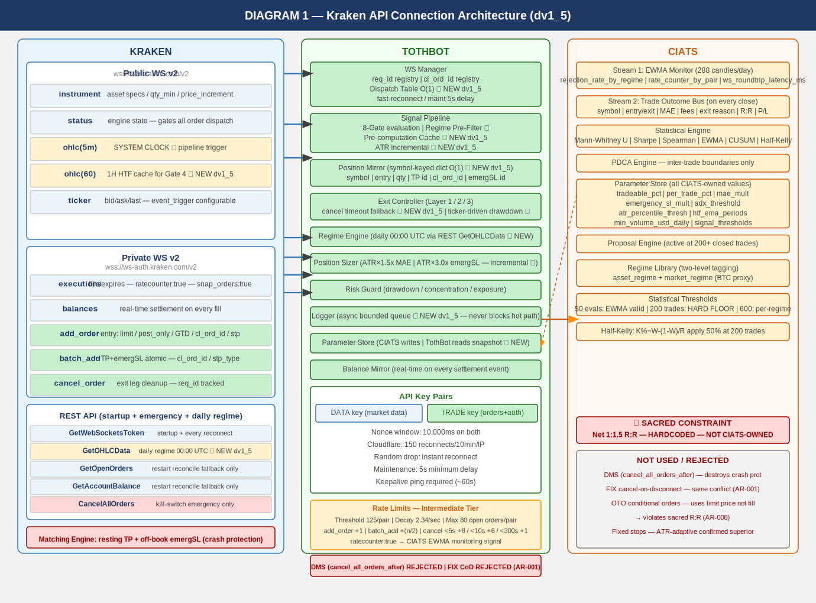

2.2 Four Kraken Engine States
State | TothBot Behavior
online | All orders. Signal pipeline runs normally.
post_only | TothBot limit+post_only entries ARE valid. Trading continues.
cancel_only | No new entries. Exit Controller can cancel. Resting TP and off-book SL stop orders active.
maintenance | No orders, no cancels, no matching. Resting TP and off-book SL stop orders active on engine.

2.3 API Rate Limits — Intermediate Tier (C-2)
Rate limits are shared across REST, WebSockets, and FIX — there is no separate per-protocol budget.
Parameter | Intermediate Tier Value
Rate counter threshold (per pair) | 125
Rate counter decay (per second) | 2.34
Max open orders (per pair) | 80
Add order fixed cost | +1
Batch add fixed cost | +(n/2) where n = orders in batch
Cancel order cost (< 5s old) | +8
Cancel order cost (< 10s old) | +6
Cancel order cost (< 300s old) | +1
Operational note: At Layer 2 MAE exit, the Exit Controller cancels both TP and emergSL before market-selling. Cancel cost depends on how long those orders have been resting. The 125 threshold per pair with 2.34/sec decay provides substantial headroom at TothBot's 5-minute candle frequency. Full rate limit specification and CIATS monitoring hooks documented in 0411003.

2.4 WS Operational Requirements (A-1 through A-5)
A-1 — Rate counter monitoring via executions channel:
The executions subscription accepts ratecounter:true. When enabled, the real-time rate counter value per pair is included in the stream at zero additional connection cost. CIATS Stream 1 EWMA Monitor adds rate_counter_by_pair as a third monitoring signal alongside rejection_rate_by_regime (F6). High or rising rate counter in a pair is early warning of execution pressure. Assign to 0511003 and 0211001.
A-2 — req_id and cl_ord_id on all outbound WS messages:
All WS v2 outbound messages carry req_id (client-specified integer). All add_order and batch_add messages additionally carry cl_ord_id (client-assigned alphanumeric identifier, up to 18 characters free text). TothBot assigns cl_ord_id at dispatch time before Kraken's response. Position Mirror records cl_ord_id immediately on dispatch — no async gap. Cancel operations may reference cl_ord_id. WS Manager maintains a pending-request registry and alerts on unacknowledged messages after timeout. Assign to 0511001, 0511003, 0511005.
A-3 — Round-trip latency monitoring and WS reconciliation:
All WS v2 responses include time_in (server receipt timestamp) and time_out (server send timestamp) to nanosecond precision. Logger records these fields. CIATS EWMA Monitor adds ws_roundtrip_latency_ms as a monitoring signal. The executions channel supports snap_orders:true on subscription — preferred over REST GetOpenOrders for restart reconciliation. REST GetOpenOrders remains as cold-start fallback. Assign to 0511001, 0511006, 0211001.
A-4 — stp_type:cancel-newest on all add_order calls:
All add_order and batch_add calls include stp_type:cancel-newest. Self Trade Prevention prevents TothBot from inadvertently filling against its own resting orders. At 5-minute candle frequency with 30-60s GTD entries, self-trade risk is low but possible if a prior GTD order has not expired when a new signal fires for the same pair. Zero-cost prevention. Assign to 0511003.
A-5 — Reconnect behavior distinction:
Two distinct reconnect behaviors: (1) Random drop — reconnect instantly, up to a handful of attempts; (2) After confirmed trading engine maintenance — minimum 5-second delay before reconnect. Both behaviors confirmed per Kraken documentation and must be implemented as separate paths in WS Manager. Assign to 0511001.

2.5 Data Architecture: Pre-Computation Cache (NEW dv1_5 — I-2)
HOT PATH RULE: The 5-minute pipeline hot path reads cached values ONLY. No computation occurs during pipeline evaluation. All indicators maintained as incremental running calculations updated on each event trigger.

Value | Pre-computed by | Update Trigger | Cache Read On
Regime classification (all pairs) | Regime Engine | Daily 00:00 UTC — REST GetOHLCData | Every 5m pipeline eval (Gate 3 + Gate 6)
1H EMA(20) and EMA(50) state (all pairs) | Signal Pipeline | 1H candle close — ohlc(60) WS event (NEW dv1_5) | Gate 4 (1H HTF Confirmation)
ATR(14) per pair | Signal Pipeline | Each 5m candle close (incremental — I-9) | Gate 8 Position Sizer + Exit Controller (Gate 7 drawdown)
24h liquidity per pair (USD) | Signal Pipeline | Daily ticker or daily OHLC pull | Gate 2 (Liquidity Gate)

3. TothBot Trading Pipeline
The pipeline fires on every 5-minute OHLC candle close event. It is synchronous and event-driven. All 8 gates incorporate FP/DP validated improvements. Gate 3 (Regime Pre-Filter) is new in dv1_5. ★ marks additions.
NOTE — OHLC fires on trade events, not wall clock: The OHLC channel publishes an updated candle only when a trade occurs in that interval. If no trades occur after an interval border, no message is sent until the next trade. The Liquidity Gate ($500k/day minimum) materially reduces this risk. The same stall behavior applies to ohlc(60) — the 1H HTF cache is updated on the first trade after each hour boundary. TothBot must handle the possibility of a delayed or stalled system clock. To be addressed in 0511002 Signal Pipeline Specification.

3.1 Gate Summary
Step | Name | Blocks / Acts When
Snapshot | Parameter Store Frozen (NEW dv1_5 — I-4) | CIATS parameter values captured as read-only snapshot at pipeline start. Consistent throughout full eval. CIATS writes applied only at inter-trade boundaries.
Cache | Pre-computation Cache Read (NEW dv1_5 — I-2) | Hot path reads: regime cache | 1H EMA cache (from ohlc-60) | ATR(14) running value | 24h liquidity. Zero computation on hot path.
Gate 1 | State Machine | Kraken engine is maintenance or cancel_only — WAIT
Gate 2 ★ | Liquidity Gate | Asset 24h volume < $500k USD — SKIP: LIQUIDITY_REJECTED
Gate 3 ★ NEW | Regime Pre-Filter (NEW dv1_5 — I-1) | TRENDING_NEG (any vol) or NON_DIR+ELEVATED — STOP: REGIME_BLOCKED. Eliminates SSS computation on all no-trade regimes. Definitive NO ENTRY check moved before expensive signal computation.
Gate 4 ★ | 1H HTF Confirmation (was Gate 3) | 1H EMA(20) <= EMA(50) for TRENDING_POS entries — SKIP: HTF_GATE_REJECTED. Cache read from ohlc(60) WS subscription (NEW dv1_5).
SSS | Signal Engine (SSS) | Scores 5-min candle. Only reached if Gate 3 pre-filter passed — wasted computation eliminated on no-trade regimes.
Gate 5 | Selection Controller (was Gate 4) | Signal fails any of 6 quality gates — SKIP: SELECTION_REJECTED
Gate 6 ★ | Regime Gate (was Gate 5) | NON_DIR+NORMAL: 50% position size. All NO ENTRY cases already blocked by Gate 3. Gate 6 now only handles position sizing for the one tradeable non-trending regime.
Gate 7 | Risk Guard (was Gate 6) | Drawdown halt triggered, concentration exceeded, exposure limit. ALSO: ticker-driven continuous drawdown monitoring for held positions between candle closes (NEW dv1_5 — I-7).
Gate 8 ★ | Position Sizer (was Gate 7) | ATR(14) x 1.5x MAE, ATR(14) x 3.0x emergSL. Never blocks — only sizes. ATR maintained as incremental running calculation (NEW dv1_5 — I-9).

EVIDENCE BASE — 1H HTF Gate and Regime Gate: 15-20% higher win rates with daily+hourly confirmation (5 independent sources 2024-2025). Market Cipher: accuracy drops 65% in trending to 45-50% in NON_DIRECTIONAL conditions. Break-even 40% for 1:1.5 R:R. Gate 3 Regime Pre-Filter eliminates computation on all definitive no-trade regimes without changing the trading decision — pure efficiency gain.

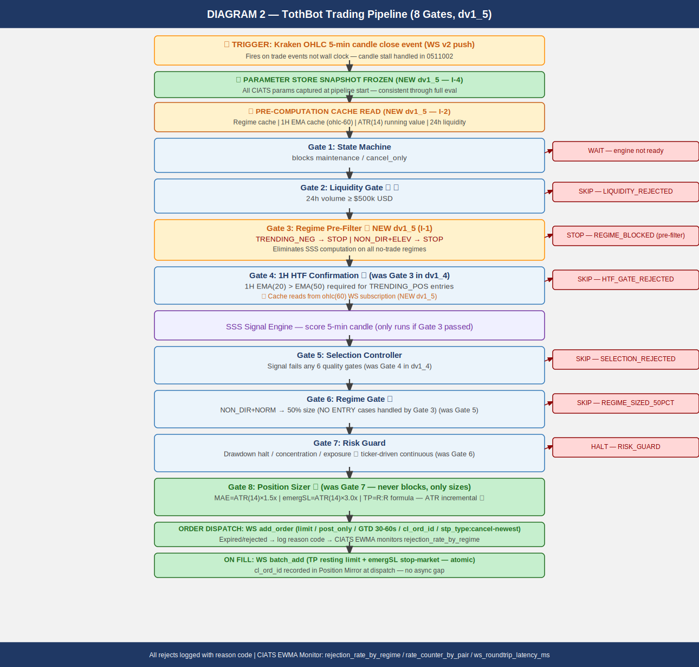

4. Exit Architecture — Ground Zero Redesign for Kraken
This exit architecture was rebuilt from zero for Kraken. It eliminates all competing exit strategies. The Exit Controller owns all normal exits. The Kraken off-book emergency SL stop order is crash protection only. OTO conditional orders were evaluated and rejected — batch_add on fill is confirmed correct (see AR-008).

4.1 Three-Layer Summary
Layer | Name | When It Fires / Behavior
1a | Signal-Based Exit | Signal decay / time expiry / momentum loss. WS cancel TP + market sell.
1b | TP Fill | Resting TP limit on Kraken matching engine fills. EC cancels emergSL after fill confirm.
2 ★ | MAE Threshold | price - entry >= ATR(14) x 1.5x. SEQUENCE CRITICAL: (1) cancel TP (2) cancel emergSL THEN (3) market sell. ★ CANCEL TIMEOUT FALLBACK (NEW dv1_5 — I-6): req_id registry tracks each cancel ACK. On timeout: check executions channel state. Confirmed cancelled: proceed. State unknown: retry once. Second timeout: ALERT + hold position + alert operator. NEVER issue market sell with ambiguous order state. Assign to 0511001 and 0511004. ★ MPP RISK (C-1 dv1_4): market sell may reject on wide spread — Exit Controller MUST handle MPP rejection and retry. Assign to 0511004.
3 ★ | Emergency Brake | VPS/TothBot/internet failure ONLY. Off-book emergSL stop order at ATR(14) x 3.0x on Kraken matching engine. NEVER in normal operation. ★ MPP RISK (C-1 dv1_4): triggered market order subject to MPP on wide spread. Assign to 0411001.

4.2 R:R Formula (Updated)
mae_pct = ATR(14) x 1.5x / entry_fill_price (CIATS-owned 1.5x multiplier, uses ACTUAL fill price)
net_loss = mae_pct + 0.16% + 0.26% (entry maker + MAE taker exit)
net_gain = net_loss x 1.5 (SACRED — hardcoded)
gross_target = net_gain + 0.16% (TP maker exit)
emergSL_dist = ATR(14) x 3.0x / entry_fill_price (NEVER in R:R formula — outside envelope)
NOTE: All calculations use actual fill price, not limit price. OTO conditional uses limit price — this is why OTO was rejected (AR-008).

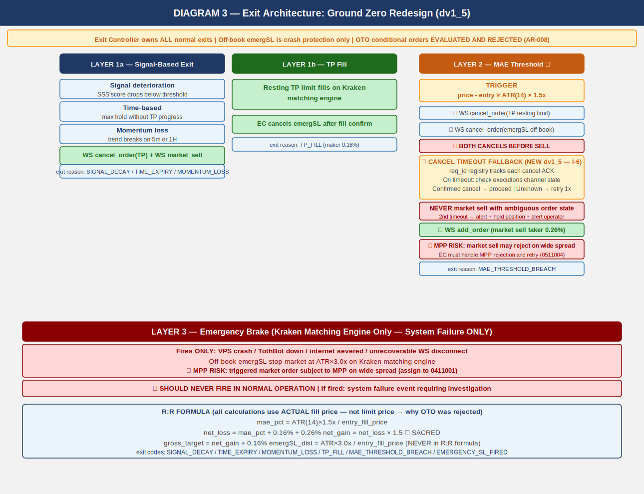

5. Regime Taxonomy
The six-regime grid is the foundation of CIATS regime-segmented analysis. Every trade is tagged with both asset_regime and market_regime (BTC proxy). Computed daily at 00:00 UTC.

5.1 Computation
DATA SOURCE (NEW dv1_5 — FLAG 2 — FP/DP VERIFIED): Daily candles via REST GetOHLCData called once per monitored pair at 00:00 UTC. Returns 720 committed daily candles. REST is the architecturally correct tool for this scheduled batch operation — not a real-time event. Zero conflict with the event-driven principle which governs real-time trading operations only. Rate counter impact: 20 pairs x 1 call/day = 0.014 calls/minute — negligible.

Directional state: ADX(14) + EMA(20) vs EMA(50) on DAILY candles (from REST GetOHLCData)
Volatility state: ATR(14) percentile rank in 50-day rolling window (from REST GetOHLCData)

TRENDING_POSITIVE: ADX(14) > 25 AND EMA(20) > EMA(50)
TRENDING_NEGATIVE: ADX(14) > 25 AND EMA(20) < EMA(50)
NON_DIRECTIONAL: ADX(14) <= 25
NORMAL_VOL: ATR percentile <= 67th
ELEVATED_VOL: ATR percentile > 67th
asset_regime + market_regime (BTC/USD proxy) both tagged on every trade

ALL REGIME THRESHOLDS ARE CIATS-OWNED: ADX threshold 25, ATR percentile 67th, EMA periods 20/50, rolling window 50 days — all starting values. CIATS validates each after 600 closed trades (100+ per regime bucket).

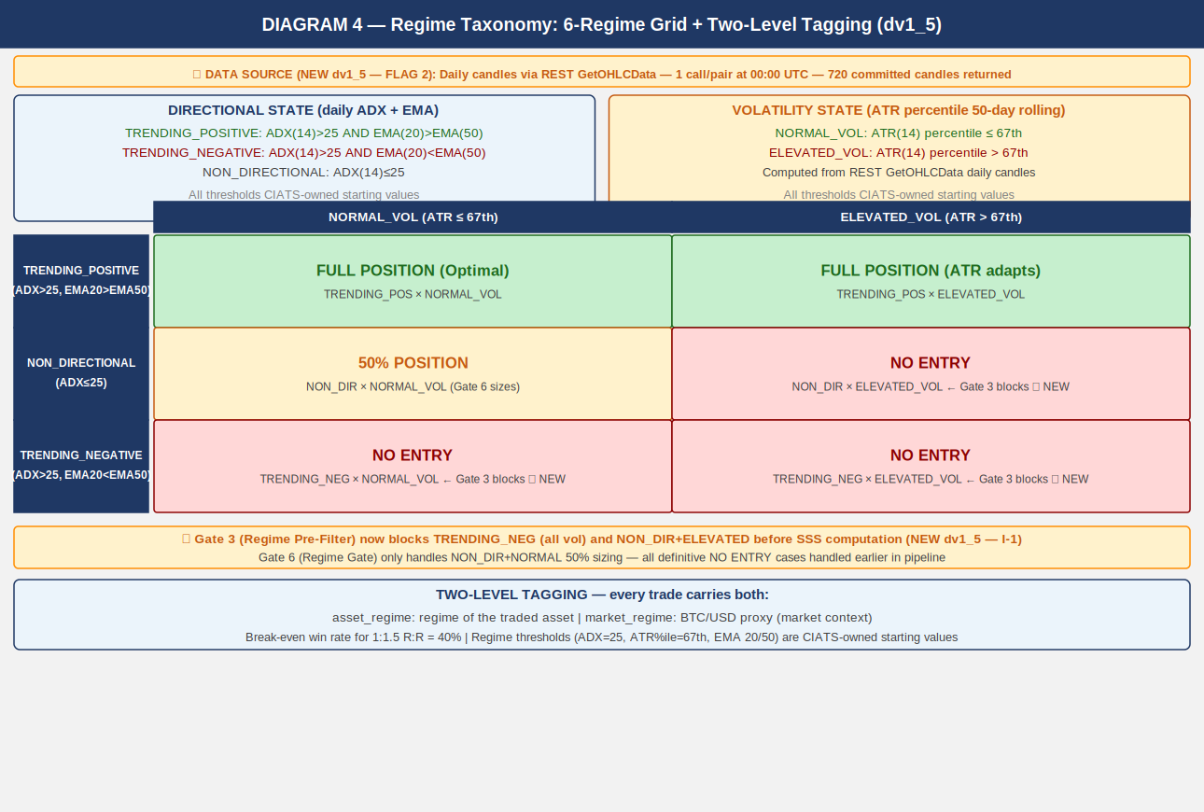

6. CIATS Architecture and Data Flows
CIATS is fully asynchronous. It never blocks the trading critical path. It reads only from the Logger and writes only to the Parameter Store. Deming PDCA governs every change.

6.1 Two Data Streams
Stream | Description
Stream 1: EWMA Monitor | 288 candle evals/day. Valid at 50 evals (~4 hrs). Detection within ~22 observations. Three monitoring signals: (1) post_only rejection_rate_by_regime (F6), (2) rate_counter_by_pair from executions channel (A-1), (3) ws_roundtrip_latency_ms from WS response timestamps (A-3). Monitoring signals ONLY — never drives parameter changes.
Stream 2: Trade Outcome Bus | Fires on each position close. Captures: symbol, entry/exit price, hold duration, MAE reached, fees, exit reason, both regime tags, signal params at entry, actual R:R, P/L.

LOGGER — ASYNC BOUNDED QUEUE (NEW dv1_5 — I-5): Logger writes go to an in-memory bounded queue. A separate async writer flushes to disk. The Logger NEVER blocks the trading hot path under any condition. Queue must be bounded with an immediate alert if queue fills. This is an architectural requirement — not optional. Assign to 0511006.

PARAMETER STORE — SNAPSHOT PATTERN (NEW dv1_5 — I-4): TothBot takes a frozen snapshot of all CIATS parameters at the start of each pipeline evaluation. The pipeline uses the snapshot throughout. CIATS writes are queued and applied only at confirmed inter-trade boundaries. Prevents parameter inconsistency within a single pipeline evaluation (e.g., per_trade_pct changing between Gate 7 and Gate 8 in the same eval). Assign to 0511002 (pipeline) and 0211001 (CIATS).

6.2 Statistical Thresholds
Threshold | Purpose
50 candle evals | EWMA Monitor valid. Fast warning stream active. Monitoring only.
20 trades | CUSUM SPC trade-level. Sensitivity detection. Not for inference.
50 trades | Health check. Detect catastrophic misalignment only.
200 trades — HARD FLOOR | Inference valid. Proposal Engine activates. Half-Kelly replaces fixed 5%.
600 trades | Per-regime analysis: 100+ per bucket. Full regime-segmented optimization.
Rolling 200-300 | Current performance window — what the system is doing NOW.
Full corpus | Zero-cost historical library. Grows perpetually. Regime comparison.

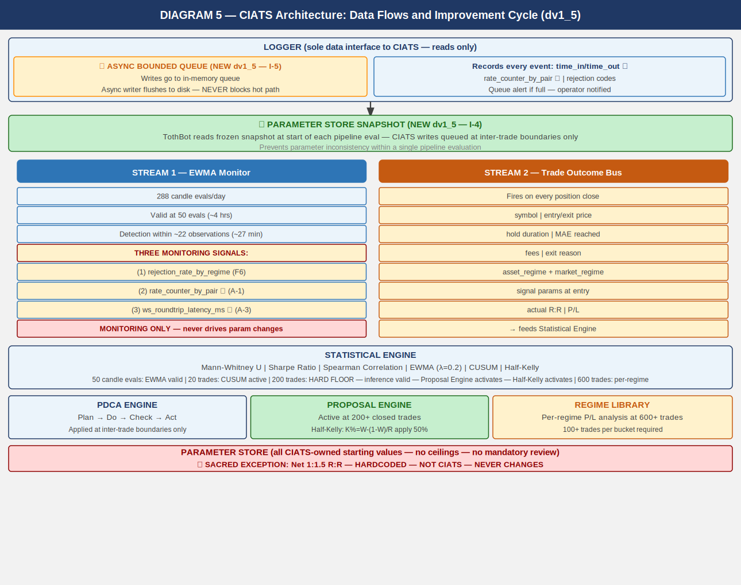

7. Complete System: One CIATS-Owned Organism
This diagram shows all three zones — Kraken, TothBot, and CIATS — as a single unified organism. Every flow and connection point is shown. ★ marks FP/DP validated additions.
CIATS OWNS EVERYTHING EXCEPT 1:1.5 R:R: All parameters, thresholds, sizing decisions, halt thresholds, multipliers, and trading rules are CIATS-owned starting values. They will be replaced by data-driven values during paper trading and live trading.

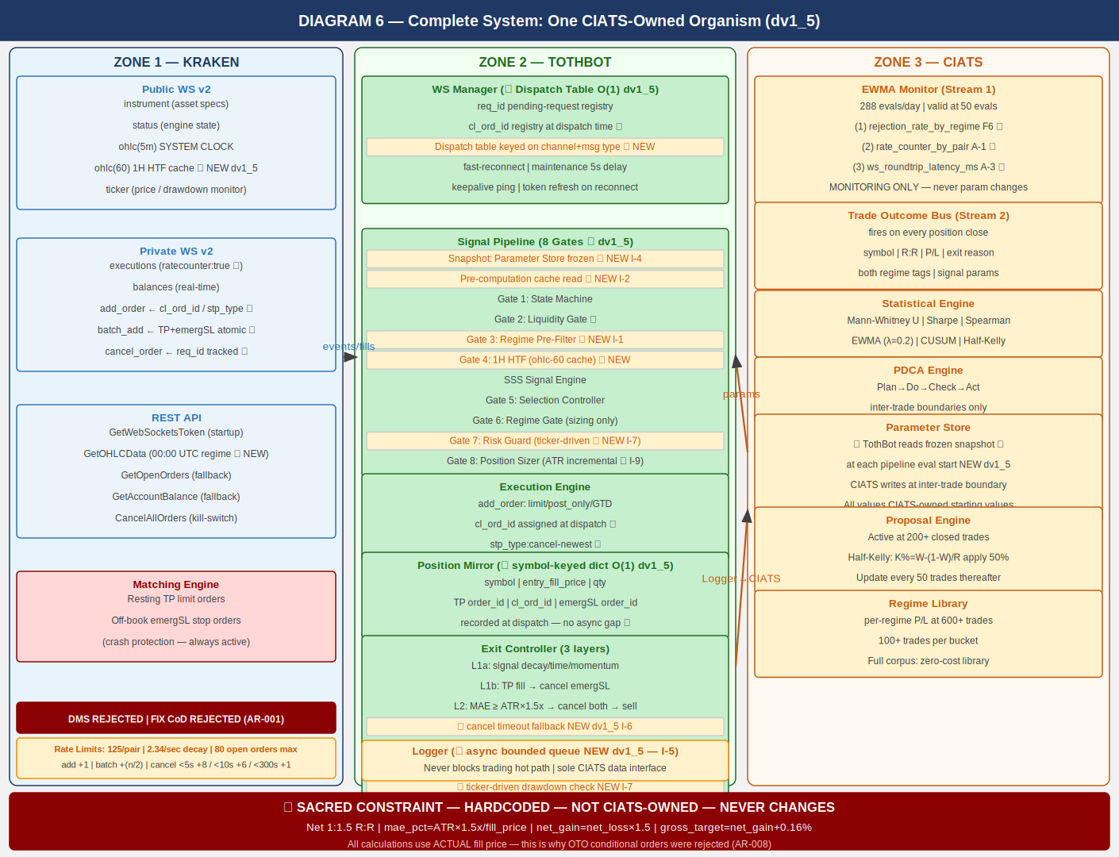

8. Locked Architectural Decisions
ID | Decision | Specification
AR-001 | No Dead Man Switch | Resting TP limit orders and off-book emergency SL stop orders on Kraken matching engine ARE the crash protection. No separate DMS thread. EVALUATED AND REJECTED: (1) cancel_all_orders_after (WS v2 DMS) — would cancel ALL orders on TothBot failure including the protective off-book emergSL stop orders. (2) FIX API cancel-on-disconnect — same architectural conflict. Both destroy the crash protection mechanism they are supposed to support.
AR-002 | Position Mirror | Symbol-keyed dict for O(1) lookup per ticker event (NEW dv1_5 — I-3). Fields: symbol (key), entry_fill_price, qty, TP order_id, cl_ord_id, emergSL order_id. cl_ord_id recorded at dispatch time before Kraken response — no async gap.
AR-003 | Restart reconciliation | PREFERRED: WS executions snap_orders:true on reconnect — provides all open orders over WS at zero REST call cost. FALLBACK: REST GetOpenOrders + GetAccountBalance — cold-start only or if snap fails. Verify emergSL orders — re-submit missing — then begin signals.
AR-004 | Two API key pairs | DATA key (market data) + TRADE key (orders + WS auth). Nonce window: 10,000ms on both.
AR-005 | WS v2 only | WS v1 not used. All future Kraken enhancements go into v2 only.
AR-006 | Entry order type | WS add_order: limit, post_only=true, GTD, expiretm=now+30-60s. cl_ord_id assigned by TothBot. stp_type:cancel-newest. CIATS-owned timeout.
AR-007 | TP placement | Resting limit via WS batch_add on entry fill. Actual fill price used for R:R calculation. Maker fee 0.16%.
AR-008 | Emergency SL placement | Stop-loss market via WS batch_add with TP in single atomic message. ATR(14) x 3.0x from actual fill price. batch_add confirmed correct — OTO conditional evaluated and REJECTED: OTO uses limit price not actual fill price, violates sacred R:R; creates Position Mirror race condition.
AR-009 | Short deferred | Kraken Derivatives US CME futures. $1,000 below margin. Activates when conditions allow.
AR-010 | 24/7/365 | No stand-down. CIATS adds via PDCA only if data supports after 200 trades.
AR-011 | Net 1:1.5 R:R — SACRED | Only hardcoded constraint. Dynamic formula using actual fill price. NEVER changed by CIATS.
AR-012 | Fee baseline | Maker 0.16% / Taker 0.26%. CIATS monitors actuals.
AR-013 | Kraken Pro — Intermediate | Confirmed sufficient for all required API permissions.
AR-014 | Logger async bounded queue | Logger writes go to in-memory bounded queue. Separate async writer flushes to disk. Logger NEVER blocks the trading hot path. Queue alert if full. Assign to 0511006. (NEW dv1_5 — I-5)
AR-015 | WS dispatch table | All incoming WS messages routed via dispatch table keyed on channel+message type. O(1) routing — no if/elif chain. Assign to 0511001. (NEW dv1_5 — I-8)
AR-016 | Incremental indicator maintenance | ATR(14) and all indicators with lookback windows maintained as incremental running calculations updated on each 5m candle close event. Never recomputed from scratch on demand. O(1) per update vs O(N) per recomputation. Assign to 0511002, 0511004. (NEW dv1_5 — I-9)
AR-017 | Daily regime via REST GetOHLCData | Regime computation is a scheduled batch operation, not a real-time event. REST GetOHLCData called once per monitored pair at 00:00 UTC. Returns 720 committed daily candles unambiguously. REST is correct tool for scheduled batch reads. FP/DP verified: WS ohlc(1440) introduces ambiguity between open and committed candles at interval boundary; REST eliminates this. Rate counter impact negligible. Assign to 0511002. (NEW dv1_5 — FLAG 2)

9. Complete CIATS Parameter Registry
ALL PARAMETERS ARE CIATS-OWNED STARTING VALUES: CIATS owns all parameters after 200-trade gate. No ceilings. No required safety reviews for sizing changes. Deming PDCA governs every change. 1:1.5 R:R net is the only exception.

Parameter | Starting Value | CIATS Changes When...
tradeable_pct | 50% of portfolio | Drawdown analysis shows over/under-exposure.
per_trade_pct | 5% → Half-Kelly at 200 trades | Kelly criterion diverges. Updates every 50 trades thereafter.
max_concurrent | 20 positions | Concentration data shows optimal concurrency.
mae_mult (ATR x) | 1.5x ATR(14) | Actual MAE distribution clusters above/below. Mann-Whitney.
emergency_sl_mult | 3.0x ATR(14) | Ratio to MAE must remain >=2x. Tail event distribution.
entry_timeout_sec | 30-60s GTD | Skip rate analysis vs fill opportunity. Spearman.
full_halt_drawdown | 10% of portfolio | Portfolio volatility distribution analysis.
session_pause_drawdown | 5% of portfolio | Session loss distribution. Mann-Whitney.
signal_thresholds | SSS gates (derived) | Signal cohort win rates diverge. Mann-Whitney.
adx_threshold | 25 | Regime classification accuracy vs trade outcomes.
atr_percentile_threshold | 67th | Vol regime accuracy vs outcome distribution.
htf_ema_periods | 20/50 daily | 1H HTF gate rejection vs signal quality outcomes.
min_volume_usd_daily | $500k USD | Post_only fill rate and SL quality vs volume floor.
1:1.5 R:R net | HARDCODED — SACRED | NOT CIATS-OWNED. The only permanent constraint in the system.

10. Six FP/DP Validated System Improvements
Derived from 80+ sources across 3 independent research passes plus two deep validation sessions (20 searches, 144+ sources total). 5+ sources per parameter. Nothing added without data. Nothing changed without justification.
Finding 1: 1H HTF Confirmation Gate [TothBot]
Gap: | No layer between daily regime and 5-min entry.
Evidence: | 15-20% higher win rates with daily+hourly filter (5 independent sources 2024-2025).
Change: | Require 1H EMA(20)>EMA(50) for TRENDING_POSITIVE entries. Cache from ohlc(60) WS subscription (NEW dv1_5). Skip logged as HTF_GATE_REJECTED.
Effect: | Removes false signals during 1H pullbacks within daily uptrends. Zero API cost.

Finding 2: ATR Dynamic Stop Distances [TothBot/Exit]
Gap: | Fixed 2% stop ignores real-time market volatility.
Evidence: | +15% performance, -22% max drawdown vs fixed stops (LuxAlgo backtesting + 4 other sources).
Change: | MAE: ATR(14) x 1.5x. Emergency SL: ATR(14) x 3.0x. Both CIATS-owned starting values. ATR maintained as incremental running calculation (NEW dv1_5 — I-9).
Effect: | Stop adapts to conditions. R:R formula preserved. Exit Controller fires before emergency SL.

Finding 3: Regime Gate [TothBot]
Gap: | Long momentum system trading in absent-edge conditions.
Evidence: | Accuracy 65%->45-50% in NON_DIRECTIONAL (Market Cipher). Break-even 40% for 1:1.5 R:R.
Change: | NON_DIR+ELEV and TRENDING_NEG: no entry (Gate 3 pre-filter — NEW dv1_5). NON_DIR+NORM: 50% size (Gate 6). Daily candles via REST GetOHLCData 00:00 UTC (NEW dv1_5).
Effect: | Stops trading when documented edge is absent. Pure loss minimization.

Finding 4: Minimum Liquidity Gate [TothBot]
Gap: | No minimum 24h volume on asset selection.
Evidence: | $1M+/day minimum for clean execution (Coin Bureau + 4 sources 2024-2025).
Change: | Asset Registry adds min_24h_volume_usd $500k starting. Checked daily via ticker.
Effect: | Protects fee formula. Ensures clean post_only fills and SL execution.

Finding 5: CIATS Half-Kelly Pathway [CIATS]
Gap: | Fixed 5% sizing had no defined data-driven transition.
Evidence: | Half-Kelly: 75% optimal growth at 50% less drawdown (MacLean-Thorp-Ziemba + 4 sources).
Change: | At 200 trades: K%=W-(1-W)/R, apply 50%. Update every 50 trades. No ceilings.
Effect: | Data-driven sizing replaces arbitrary fixed fraction after sufficient data.

Finding 6: post_only Rejection Monitoring [CIATS]
Gap: | Rejection events logged but unused by CIATS EWMA.
Evidence: | Rejection rate = direct signal of entry placement quality (Cube Exchange + 4 sources).
Change: | CIATS EWMA adds rejection_rate_by_regime stream. High rate in TRENDING = miscalibrated.
Effect: | Free diagnostic signal already in Logger. Entry optimization pathway activated.

11. Complete Trade Lifecycle — Narrative Reference

11.1 Normal Trade (Entry to TP or Exit Controller)
OHLC 5-min candle close fires on public WS v2
Parameter Store snapshot frozen — all CIATS params captured for this eval (NEW dv1_5 — I-4)
Pre-computation cache read — regime, 1H EMA, ATR(14) incremental, 24h liquidity (NEW dv1_5 — I-2)
Gate 1: State Machine — online or post_only: continue; else halt and wait
Gate 2: Liquidity Gate — 24h volume >= $500k: continue; else skip
Gate 3: Regime Pre-Filter — TRENDING_NEG or NON_DIR+ELEV: STOP; else continue (NEW dv1_5 — I-1)
Gate 4: 1H HTF Gate — 1H EMA(20) > EMA(50) for TRENDING_POS: continue; else skip (cache from ohlc-60)
Signal Engine: SSS score computed on 5-min candle
Gate 5: Selection Controller — 6-gate quality evaluation: pass or reject
Gate 6: Regime Gate — TRENDING_POS: proceed; NON_DIR+NORM: 50% size
Gate 7: Risk Guard — drawdown/concentration/exposure checks: pass or halt
Gate 8: Position Sizer — MAE = ATR x 1.5x (incremental), emergSL = ATR x 3.0x, TP = R:R formula
Execution: WS add_order (limit, post_only, GTD expiretm=now+30-60s, cl_ord_id assigned, stp_type:cancel-newest)
If expired/rejected: log reason code -> CIATS EWMA monitors rejection rate. Done.
If filled: WS batch_add -> TP (resting limit) + emergSL (stop-market) atomic. cl_ord_id recorded.
Position Mirror records: symbol (key), entry_fill_price, qty, TP order_id, cl_ord_id, emergSL order_id
Exit Controller monitors via ticker (continuous drawdown check — NEW dv1_5 — I-7)
Logger records full entry via async queue (time_in/time_out). CIATS Trade Outcome Bus ready.
TP fills: EC cancels emergSL. Or EC fires Layer 1/2 exit. Position closes.
Logger records full exit. CIATS Trade Outcome Bus fires with complete trade record.

11.2 Layer 2 MAE Exit (Adverse Price)
Exit Controller detects: current_price - entry >= ATR(14) x 1.5x (from incremental ATR cache)
WS cancel_order: cancel TP resting order
WS cancel_order: cancel emergSL stop order (off-book) -- SEQUENCE CRITICAL: both cancels before market sell
CANCEL TIMEOUT FALLBACK (NEW dv1_5 — I-6): req_id registry tracks each cancel ACK. On timeout: check executions channel state. If order confirmed cancelled: proceed to next step. If state unknown: retry once. If second timeout: ALERT and hold position — alert operator immediately. NEVER issue market sell with ambiguous order state. Assign to 0511001 (WS Manager timeout behavior) and 0511004 (Exit Controller fallback logic).
WS add_order: market sell (taker 0.26%)
MPP NOTE (C-1 dv1_4): Market sell subject to MPP enforcement. May reject if bid/ask spread wide during adverse move. Exit Controller MUST handle MPP rejection and retry. Specification assigned to 0511004.
Logger: exit reason = MAE_THRESHOLD_BREACH
CIATS Trade Outcome Bus fires

11.3 Emergency SL (Layer 3 — System Failure Only)
VPS crashes / TothBot dies / internet severs / unrecoverable WS disconnect
Kraken matching engine fires off-book emergency SL stop-market order at ATR x 3.0x
MPP NOTE (C-1 dv1_4): The triggered market order is subject to MPP enforcement. May reject on wide spread at time of trigger. Specification assigned to 0411001.
On restart: reconciliation detects closed position -> Logger: EMERGENCY_SL_FIRED
This is a system failure event requiring investigation. SHOULD NEVER FIRE IN NORMAL OPERATION.

12. Open Items — Require Specification Documents
# | Item | Description
001 | Signal generation (SSS) | SSS scoring model re-derived from first principles for Kraken Spot.
002 | Asset selection universe | Kraken USDT/USDC pairs — eligibility criteria beyond liquidity gate.
003 | Exit Controller spec | Complete: signal decay thresholds, time exit rules, momentum detection, full L1/L2 decision tree. MPP rejection handling required (C-1 dv1_4). Cancel timeout fallback behavior required (I-6 dv1_5). OTO conditional evaluated and rejected — batch_add confirmed correct.
004 | Entry limit placement | Exact rule for post_only limit price relative to bid/ask spread. Evaluate ticker event_trigger:bbo during derivation. Evaluate L2 book channel for spread monitoring (PL-010).
005 | Selection Controller | 6-gate formal specification.
006 | CIATS specification | Full spec: all interfaces, methods, PDCA workflows, regime library format. Parameter Store snapshot pattern (I-4 dv1_5). Async Logger interface (I-5 dv1_5).
007 | AA=04 Exchange Interface | Formal controlled document incorporating all decisions in this overview.
008 | All AA=10 coding specs | Full coding specs for every module, infrastructure component, and test suite.

13. Revision History
Version | Date | Description
dv1_0 | 03-23-2026 | Initial document. All architectural decisions, FP/DP improvements, exit architecture ground zero redesign, regime taxonomy, CIATS ownership model, and complete system flow.
dv1_1 | 03-23-2026 | Added all six system flow diagrams.
dv1_2 | 03-24-2026 | Six changes from deep API validation search. (C-1) Emergency SL terminology corrected. (C-2) Rate limits added Section 2.3. (C-3) OHLC stall documented. (A-1) ratecounter:true. (A-2) req_id mandatory. (A-3) time_in/time_out latency logging.
dv1_3 | 03-24-2026 | Rebuilt as correct .docx with all six diagrams embedded. dv1_2 produced in error without diagrams.
dv1_4 | 03-24-2026 | Seven changes from second deep API validation search. (C-1) MPP always enforced. (A-1) AR-001 expanded with DMS and FIX rejection. (A-2) cl_ord_id added. (A-3) snap_orders preferred reconciliation. (A-4) stp_type:cancel-newest. (A-5) Reconnect distinction. (A-6) OTO rejected.
dv1_5 | 03-24-2026 | Eleven changes from internal architecture deep dive and FP/DP analysis of data sources. (FLAG 1) ohlc(60) added to Public WS v2 for 1H HTF Gate 4 cache — FP/DP verified, event-driven, no new connections. (FLAG 2) REST GetOHLCData at 00:00 UTC for daily regime computation — FP/DP verified, correct for scheduled batch operation, eliminates open/committed candle ambiguity of WS ohlc(1440). AR-017 added. (I-1) Gate 3 Regime Pre-Filter added — blocks TRENDING_NEG and NON_DIR+ELEVATED before SSS computation, eliminating wasted signal scoring on no-trade regimes. Gate numbering advanced to 8 gates total. (I-2) Pre-computation cache documented in Section 2.5 and pipeline — hot path reads only, never computes. (I-3) Position Mirror updated to symbol-keyed dict for O(1) lookup — AR-002 updated. (I-4) Parameter Store snapshot pattern documented — frozen at pipeline start, CIATS writes at inter-trade boundaries only. AR-014 added. (I-5) Logger async bounded queue documented — never blocks hot path. AR-014 added. (I-6) Layer 2 cancel timeout fallback specified — req_id registry, executions channel state check, NEVER market sell with ambiguous order state. Section 4.1 and 11.2 updated. (I-7) Gate 7 Risk Guard extended to ticker-driven continuous drawdown monitoring between candle closes. (I-8) WS dispatch table O(1) routing documented. AR-015 added. (I-9) ATR(14) incremental running calculation documented. AR-016 added. All six flow diagrams updated.

